[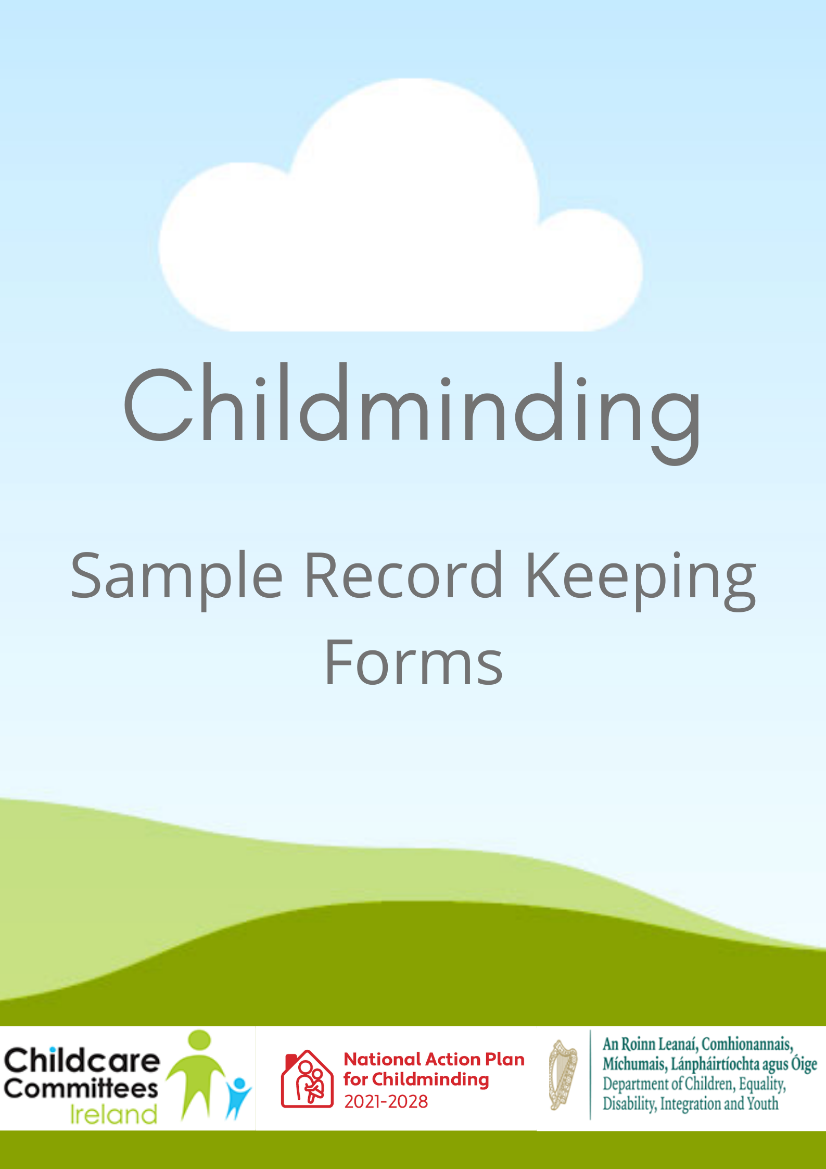

This document was developed by the Childminding Development Officer Team in September 2020 under the National Action Plan for Childminding 2021 – 2028. Version 2 updated September 2021.

The Childminding Development Officers provide support to the local City and County Childcare Committees to work with existing and potential childminders to deliver a high-quality early learning and care and/or school age service to meet the requirements of individual children, families and communities.

The Childminding Development Officer team would like to acknowledge that the material in this pack has been adapted from resources previously developed and published by the City and County Childcare Committees (CCCs) and Tusla.

**Disclaimer:**

The Childminding Development Officers have made every effort to ensure that all the information included in this publication is accurate and correct. However, under no circumstances will the board of any City/County Childcare Committee be liable in respect of any error(s), omissions, typographical errors or incorrect information therein.

The Childminding Development Officers assumes no liability whatsoever for any damage resulting from use of this publication, associated resources or its contents.

# Contents

Sample Contract between Childminder & Parent 4

Sample Medication Consent Form 9

Sample Medication Administration Record 10

Sample Accident and Incident Form 11

Sample Risk Assessment Form 15

Sample Nappy Changing Procedure 16

Sample Hand Washing Procedure 17

Respiratory Hygiene 18

Symptoms: Meningitis & Septicaemia 19

Sample Attendance and Fees Sheet. 20

Sample Menu Planner 21

Sample Child’s Record 22

Sample Fire Drill Record 30

Sample First Aid Checklist 31

Sample Flexible Daily Routine 32

Voluntary Notification Form 33

**Please note that sample record keeping forms outlined in this document are not an exhaustive list and childminders may need to develop additional policies and procedures to suit their individual childminding service.**

# Sample Contract between Childminder & Parent

**Childminder Contact Details**

Name of Childminder:

Address:

….

Phone Number: ……………………………………… Mobile no: ………………………………………

**Parent/Guardian Contact Details**

Name of Parent/Guardian: ………………………………………………………………………………

Address: .

….

Phone no: ………………………… Work no: ……………………. Mobile no: ……………………

Name of Child: ……………………………………………………………………………

Address (if different from above): ………

**Collection:**

Child/ren will be collected by (include names and relationship to the Child.)

_________________________________________________

_________________________________________________

__________________________________________________

The Child/ren will not be handed to any other person unless prior instruction has been given personally to the Childminder.

**Childminding start date: / /**

**Morning: Afternoons: Evening/Overnight:**

Monday Start­­____ Finish____ Start­­____ Finish____ Start­­____ Finish____

Tuesday Start­­____ Finish____ Start­­____ Finish____ Start­­____ Finish____

Wednesday Start­­____ Finish____ Start­­____ Finish____ Start­­____ Finish____

Thursday Start­­____ Finish____ Start­­____ Finish____ Start­­____ Finish____

Friday Start­­____ Finish____ Start­­____ Finish____ Start­­____ Finish____

Saturday Start­­____ Finish____ Start­­____ Finish____ Start­­____ Finish____

**Childminding Details**

**Childminder to provide:**

Breakfast □ Lunch □ Snacks □ Dinner □

Other □ Specify _________________________________________________________

The cost of providing food is / is not included in the fees

**Parent to provide:**

Nappies □ Food □

Change of clothes □ Baby toiletries □

Sunscreen □

Other ­­­______________________________________________________________________

Cost of transport, outings to be covered by ________________________________________

**Payment**

**Electronic payment is preferred. My bank details are:**

**IBAN: __________________________________________________________________­­­_____**

**BIC: ________________________________________________________________________**

**Bank Name: _________________________________________________________________**

**Bank Address: ________________________________________________________________**

Rate of pay is € _______ per hour per child

Payment to be paid weekly in advance every Thursday

**Fee for late pick-up:** € _______

Non-refundable deposit of €_______ required.

**Sickness**

**Children should not attend if they have an infectious illness.**

**Children should not attend if they have symptoms of Covid-19 or any other contagious illness.**

**Fees to be paid in the event of:**

Childminder sickness: Yes/No

Parent sickness: Yes/No

Child sickness: Yes/No

**Parental Declaration during Covid-19**

1. My child/ren will not attend this service if they or someone in our household has symptoms of Covid-19.
2. If my child becomes symptomatic, I will collect them and contact our doctor. If testing is arranged for my child, I understand that local public health staff will be in touch with me where a test is positive. I also understand that the local public health staff will be in touch with the childminding setting in relation to what steps are required for me, the service and other families.
3. I have read (Childminders Name) Infection Control Policy and agree to adhere to it.
4. I will provide a spare set of clothes and other essential items which must remain in the childminding setting.
5. I will not allow toys from home to be brought into the childminding setting at this time.
6. I agree to commit to the HSE advice to ensure risks are avoided.
7. I consent to my child/ren attending your service and mixing with other families supported by their Childminder.
8. I will inform (Childminders Name) if my child/ren have symptoms of Covid-19.
9. I am aware that this service may have to shut immediately, subject to public health advice, if any person reports symptoms of Covid-19.
10. I am aware that I may also be asked to self-isolate or restrict my movement, again subject to public health advice.
11. If soft toys/ comfort blankets are essential for my child, they will be personal to my child, will be machine washable and they cannot be shared.

Please state if you or your child has been in contact with anyone who presented symptoms of Covid-19 or tested positive for Covid-19 ___________________________Y/N

Parent’s signature: _______________________________________ Date: ______________________

Childminder’s signature: __________________________________ Date: _______________________

**Holidays/Annual Leave**

**Childminder Annual Holidays**

Number of days paid holiday per year (including public holidays): _________________

Notice required of annual leave: _________________

**Parent Annual Holidays**

Number of days paid holiday per year (including public holidays): _________________

Notice required of annual leave: _________________

**Other Holidays:**

Bank Holidays Fee: Yes/No

Occasional day/s off (Parent) Fee: Yes/No

Occasional day/s off (Childminder)Fee: Yes/No

**Contract Review**

This contract will be reviewed every: _________________________

Next review date: ______________________

**Notice to end the Childminding Arrangement.**

The required notice period from **either** party is _______ _________. Payment in lieu of notice is payable to the Childminder where the notice period agreed is not complied with.

**Childminder’s Signature:_____________________________ Date:_________________________**

**Parent or Guardian Signature: _________________________ Date: ________________________**

**The above contract has been adapted from Childminding Ireland’s: Sample Childminding (Covid-19) Contract with Parents.**

# Sample Medication Consent Form

|  |  |
| --- | --- |
| **Child’s full name:** |  |
| **Child’s address:** |  |
| **Date of Birth:** |  |
| **Details of medical condition (what medicine is for):** |  |
| **Name of medicine:** |  |
| **Name and contact details of prescriber:** |  |
| **Dosage of medicine:** |  |
| **Route for administration of medicine (circle correct one):** | Oral (by mouth) Topical (rub in) Inhale  Injection Rectal |
| **Frequency of dosage/ times to be given:** |  |
| **Effective from**  **Effective to** | Date:  Date: |
| **Any other information** **(side effects, potential adverse reaction, special precautions):** |  |
| **How the medication is to be stored (as on directions given on medication label):** |  |
| **Printed name of parent:** |  |
| **Signature of parent or guardian authorising medicine:** |  |
| **Date:** |  |

# Sample Medication Administration Record

Each time medication is to be administered, I first:

* Confirm the child’s identity
* Check that parent’s/guardian’s written consent has been given
* Check when medicine was last given
* Check the administration instructions, including the name of the medication,

the method and times for administration and the required dose

* Check whether medication is within date

**Child’s name:**

|  |  |  |  |  |  |  |  |
| --- | --- | --- | --- | --- | --- | --- | --- |
| **Date** | **Time** | **Name of Medication**  **(state whether prescribed or non-prescribed)** | **Dose Given** | **Route of administration**  **(by mouth, injection, inhale, rectal, topical – rub in)** | **Signature of person administering** | **Signature**  **of witness** | **Comments** |
|  |  |  |  |  |  |  |  |
|  |  |  |  |  |  |  |  |
|  |  |  |  |  |  |  |  |
|  |  |  |  |  |  |  |  |

# Sample Accident and Incident Form

|  |  |  |  |
| --- | --- | --- | --- |
| **Name of child/adult affected:** |  | **Date of Birth of child/adult:**  **Age of child/adult:** |  |
| **Name of person dealing with the accident/incident:** |  | **Date and time of accident/incident:** |  |
| **Place of the accident/incident:** |  | **Detailed description of the accident/incident:** |  |

|  |
| --- |
| **Details of the accident area/layout, including the number of adults and children present:** |
|  |
| **Details of all communication with parents/guardians in relation to the accident/incident:** |
|  |
| **Details of any investigation completed in relation to the accident/incident:** |
|  |
| **Details of all required corrective and preventative actions taken:** |
|  |
| **Details of any changes made to policy and/or practice, following review of accident/incident:** |
|  |
| **Details of whether the incident/accident has been notified to Tusla:** |
|  |

|  |  |
| --- | --- |
| **Circumstances surrounding the accident/incident, including any apparent illness or symptoms:** |  |
| **Name of parents/guardians contacted and time they were contacted:** |  |
| **Nature of the injury:** |  |
| **Treatment provided (medication or First Aid administered)** |  |
| **Medical personnel or emergency services contacted and time of contact:** |  |
| **Details of any person(s) present:** |  |
| **Details and signatures of any witness(es):** |  |
| **Name of those to whom the accident was notified and date and time:** |  |
| **When the child was collected/removed to hospital and by whom:** |  |

|  |
| --- |
| **Details of the accident area/layout, including the number of adults and children present:** |
|  |
| **Details of all communications with parents/guardians in relation to the accident/incident:** |
|  |
| **Details of any investigation completed in relation to the accident/incident:** |
|  |
| **Details of all required corrective and preventative actions taken:** |
|  |
| **Details of any changes made to policy and/or practice, following review of accident/incident:** |
|  |
| **Details of whether the incident/accident has been notified to Tusla:** |
|  |

|  |  |  |  |  |  |
| --- | --- | --- | --- | --- | --- |
| **Notification details to other external parties** | | | | | |
| **Notified to** | **Yes** | **No** | **Date** | **Details** |
| Tusla Social Work Services (if there is a child protection concern) |  |  |  |  |
| An Garda Síochána (where this is a danger to staff or children or a criminal offence) |  |  |  |  |
| Health and Safety Authority (where the incident is dangerous or staff member has been injured as a result) |  |  |  |  |
| The service’s insurance (where appropriate) |  |  |  |  |

|  |  |
| --- | --- |
| **To be completed by parent(s)/guardian(s)** | |
| **Print Name(s):** |  |
| **Signature(s):** |  |
| **Time & Date:** |  |

|  |  |
| --- | --- |
| **To be completed by the person writing the report** | |
| **Print Name:** |  |
| **Signature:** |  |
| **Time & Date:** |  |

|  |  |
| --- | --- |
| **Review and close off - To be completed by the Childminder** | |
| **Print Name:** |  |
| **Signature:** |  |
| **Date:** |  |

# Sample Risk Assessment Form

|  |  |  |  |  |
| --- | --- | --- | --- | --- |
| **Identify potential hazard/risk** | **Current controls in place** | **Assess the risk** | **Additional controls to eliminate/reduce the risk** | **Person responsible for implementing the controls** |
|  |  |  |  |  |
|  |  |  |  |  |
|  |  |  |  |  |
|  |  |  |  |  |
|  |  |  |  |  |
|  |  |  |  |  |

#### 

# Sample Nappy Changing Procedure**[1]**

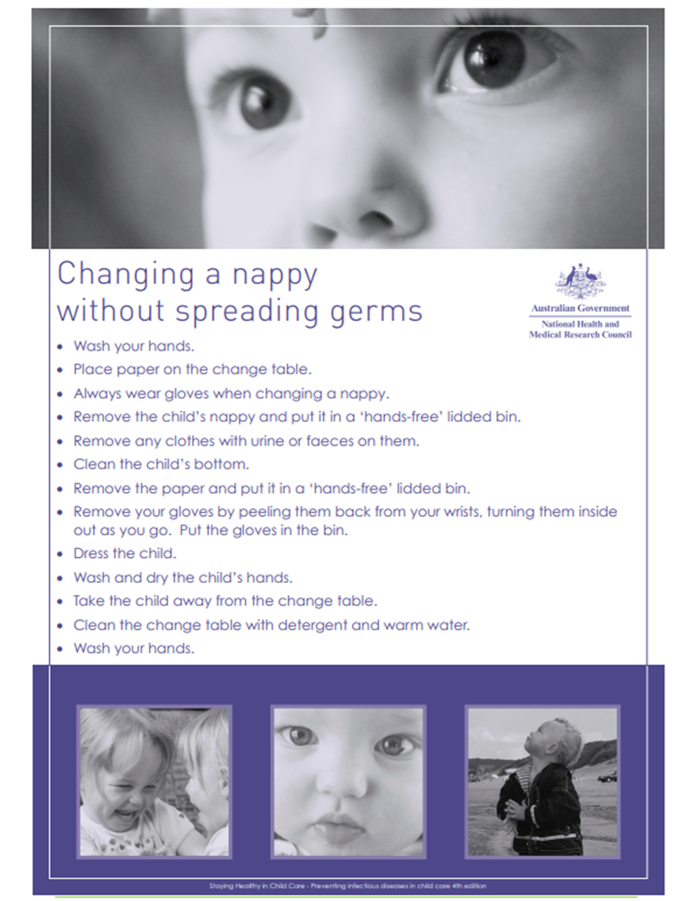

# Sample Hand Washing Procedure**[2]**

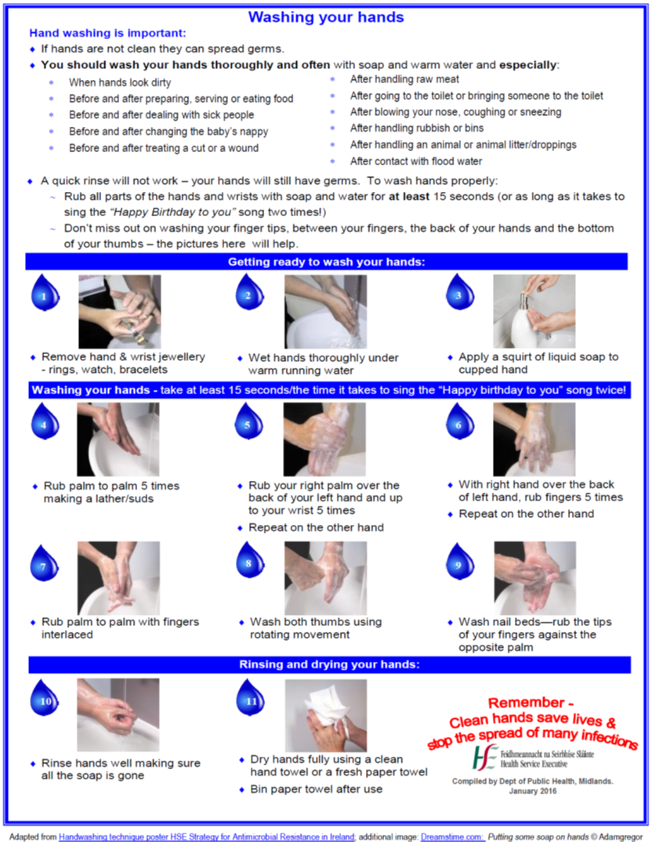

# Respiratory Hygiene

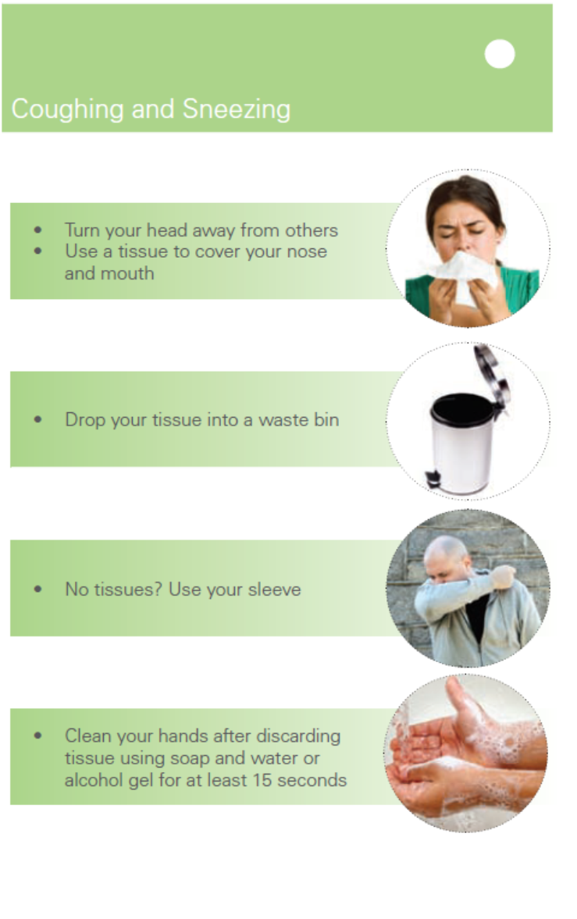

# Symptoms: Meningitis & Septicaemia



# Sample Attendance and Fees Sheet

|  |  |  |  |  |  |  |
| --- | --- | --- | --- | --- | --- | --- |
| **Child’s Name** |  | **Monday** | **Tuesday** | **Wednesday** | **Thursday** | **Friday** |
|  | Arrive |  |  |  |  |  |
| Leave |
|  | Arrive |  |  |  |  |  |
| Leave |
|  | Arrive |  |  |  |  |  |
| Leave |
|  | Arrive |  |  |  |  |  |
| Leave |
|  | Arrive |  |  |  |  |  |
| Leave |
| **Signed by Childminder** |  |  |  |  |  |  |

# Sample Menu Planner

***Week Beginning:***

|  |  |  |  |  |
| --- | --- | --- | --- | --- |
| ***Day*** | ***Breakfast*** | ***Snacks*** | ***Lunch*** | ***Dinner*** |
| ***Monday*** |  |  |  |  |
| ***Tuesday*** |  |  |  |  |
| ***Wednesday*** |  |  |  |  |
| ***Thursday*** |  |  |  |  |
| ***Friday*** |  |  |  |  |

# Sample Child’s Record

**Child’s Record Form**

Name of Childminder or Service: ____________________________________________________________

Child’s Full Name: _________________________ Child’s preferred name: _____________________________

Date of birth: ___/___/___ Sex: Female: ( ) Male: ( )

Date child commenced with Childminder: ___/___/___

Date child ceased to attend Childminder: ___/___/___

Home Address: ______________________________________________________________________________________________________________________________________________________________________________________________________________________________________________________________________________

Change of address: ______________________________________________________________________________________________________________________________________________________________________________________________________________________________________________________________________________

**Details of Parents/Guardians**

Name: (1) _______________________ (2)____________________________

Relationship to Child: (1) _______________________ (2)_____________________________

Home Tel no: (1) _______________________ (2)_____________________________

Mobile number : (1) ______________________ (2)_____________________________

Contact email : (1) _______________________ (2)_____________________________

Home address of parent if different from above: ____________________________________________________________________________________________________________________________________________________________________________________

Who does the child live with? _________________________________________________________________

Do both parents have custody of the child, if not please give details:

__________________________________________________________________________________________

Child’s country of origin: _____________________________________________________________________

Parent’s country of origin: ____________________________________________________________________

Child’s first language: ________________________________________________________________________

Parent/Guardian’s first language: _______________________________________________________________

**Work Details**

Place of Work: (1) ________________________ (2) _____________________

Work contact no: (1) ________________________ (2) _____________________

Work email: (1) ________________________ (2) _____________________

**Person(s) authorised to collect my child (other than the parents)**

Name: (1)__________________________­­­ (2) _____________________________

Address: (1)__________________________ (2) _____________________________

Relationship to child: (1)__________________________ (2)______________________________

Contact no: (1)__________________________ (2) _____________________________

Mobile: (1)__________________________ (2) _____________________________

Name: (3)__________________________­­­

Address: (3)__________________________

Relationship to child: (3)__________________________

Contact no: (3)__________________________

Mobile: (3)__________________________

**Nominated Emergency Contacts**

Name: (1)__________________________­­­ (2) _____________________________

Address: (1)__________________________ (2) _____________________________

Relationship to child: (1)__________________________ (2)______________________________

Contact no: (1)__________________________ (2) _____________________________

Mobile: (1)__________________________ (2) _____________________________

Date form filled in: ___/___/___ Information updated: (1) ___/___/___ (2) ___/___/___

**Medical History**

Does your child suffer from any medical conditions, illness, and/or allergies? _________________________________________________________________________________________

Is your child on any medication? _________________________________________________________________________________________

Has your child been hospitalised for any major illness or injury, if so please give details: _________________________________________________________________________________________

Family Doctor: ______________________________________________________________________________

Address: ___________________________________________________________________________________

Tel no: ____________________________________________________________________________________

Web Address: ______________________________________________________________________________

**Immunisation Record (Please enter date received)**

|  |  |  |  |
| --- | --- | --- | --- |
| **Age** | **Where** | **Vaccine** | **Date Received** |
| Birth | Hospital/Clinic | BCG (TB) |  |
| 2 Months | GP | 6 in 1  + PCV + MenB + Rotavirus  (3 injections + oral drops) |  |
| 4 Months | GP | 6 in 1 + MenC + Rotavirus  (2 injections + oral drops) |  |
| 6 Months | GP | 6 in 1 + Men C + PCV  (3 injections) |  |
| 12 Months | GP | MMR + PCV  (2 injections) |  |
| 13 Months | GP | MenC + Hib + PCV  (2 injections) |  |
| 4-5 Years | GP/School | 4 in 1 + MMR  (2 injections) |  |

In Ireland it is not a statutory requirement that children must be immunised (vaccinated) in line with the National immunisation schedule. This is a parent’s choice. **It is highly desirable that children are vaccinated** in accordance with the schedule unless contraindicated for medical reasons as children who are not vaccinated are dependent on “herd immunity” to protect against disease.

Vaccination protects the individual immunised who is less likely to be a source of infection to others. This reduces the risk to unimmunised individuals being exposed to infection. Thus, individuals who have not been immunised, or those who cannot be immunised, get some benefit from the immunisation programme. This concept can also be called population immunity.

**The Childminder must keep a record of immunisations, if any, received by the child**; so they must be aware of children attending the service who are vaccinated and those who are not vaccinated so that those children who are not vaccinated can be best protected in the event of such an infectious disease occurring within service. Further immunisation Information can be accessed [here](https://www.hse.ie/eng/health/immunisation/pubinfo/pcischedule/engmagnetposter.pdf)

**Additional Information:**

Tell me about your child’s strengths, interest areas, abilities or challenges in which I can support them with?

____________________________________________________________________________________

____________________________________________________________________________________

Please outline details and special requirements if any: ____________________________________________________________________________________

____________________________________________________________________________________

Has your child been assessed for any hearing and/or speech difficulties? ____________________________________________________________________________________

____________________________________________________________________________________

Please outline details and special requirements if any: ____________________________________________________________________________________

____________________________________________________________________________________

Does your child have any specific dietary/cultural requirements? ____________________________________________________________________________________

____________________________________________________________________________________

Please outline details:

____________________________________________________________________________________

____________________________________________________________________________________

Does your child have any fears or phobias and if so please describe?

____________________________________________________________________________________

____________________________________________________________________________________

Name of siblings and/or close personal relationships in your child’s life: ____________________________________________________________________________________

____________________________________________________________________________________

Does your child have any special talents/areas of interest? ____________________________________________________________________________________

____________________________________________________________________________________

Does your child use ‘pet’ language for special comfort toys? ____________________________________________________________________________________

____________________________________________________________________________________

Notes provided by parents concerning the above are attached to file:

Yes ____ No___

**Parental Consent Form**

1. **Emergency Medical Care**

I understand that every effort will be made to contact the named guardian or next of kin in the event of an emergency, requiring medical attention. However, if none of these can be contacted I hereby authorise the Childminder to transport my child to the doctor’s surgery or to the appropriate hospital A/E department by ambulance or as is necessary and to secure the necessary medical treatment for my child. I give my permission for my child to be given appropriate emergency medical treatment.

Patient Number if the child attends any clinics/specialists in the hospital: _________________

Parent/Guardian’s signature: ________________________________ Date: ___/___/____

**2. First Aid**

I authorise that the Childminder trained in First Aid may administer First Aid to my child as appropriate.

Parent/Guardian’s signature: ________________________________ Date: ___/___/___

**3. Antipyretic**

I consent to teething gels and temperature control medication in accordance with the policy and procedures of the Childminder.

**NB: Parents will always be informed when medication has been administered to their child.**

Parent/Guardian’s signature: ________________________________ Date: ___/___/___

**4. Permission for Outings**

I authorise that my child may be taken on outings/walks that may be planned outside the Childminders home. The adult/child ratio for these outings will be based on a risk assessment carried out prior to the outing taking place. I understand that all necessary precautions will be taken to ensure my child’s safety.

Parent/Guardian’s signature: ________________________________ Date: ___/___/___

**5. Internet, Photo and Recording Permission**

I give permission for _______________________________(child’s name) to access the **internet.** The Internet is used only for brief periods and to support children’s learning in accordance with the childminding service policy.

I give permission for ___________________________________(child’s name) to be **photographed** or **recorded.** Photographs/recordings may be used for:

* + Giving feedback to parents
  + Viewing activities and progress, either currently or retrospectively
  + Enhancing the health, welfare, and development of your child
  + Supporting the annual review of the service
  + Identifying potential risks
  + Inspection

Parent/Guardian’s signature: _____________________________ Date: ___/___/___

**6. Access to Pets**

I give permission for my child to be in contact with or have supervised access to pets. Care will be taken to ensure that the health, safety, and welfare of the children is not put at risk.

Parent/Guardian’s signature: ________________________________ Date: ___/___/___

**7. Sun Cream Permission**

I give permission for the application of sun cream to my child as outlined in the Childminders sun protection policy.

Parent/Guardian’s signature: ________________________________ Date: ___/___/___

**8. Parent/Childminder Declaration**

I have read and understand the policies referred to above. I will notify the Childminder of changes to any of the details in this form.

Parent/Guardian’s signature: ________________________________ Date: ___/___/___

Childminders signature: ___________________________________ Date: ___/___/___

# Sample Fire Drill Record

|  |  |  |  |  |  |  |
| --- | --- | --- | --- | --- | --- | --- |
| Month | Date | Time of Drill | Number of adults | Number of Children | Comment | Signed |
| January |  |  |  |  |  |  |
| February |  |  |  |  |  |  |
| March |  |  |  |  |  |  |
| April |  |  |  |  |  |  |
| May |  |  |  |  |  |  |
| June |  |  |  |  |  |  |
| July |  |  |  |  |  |  |
| August |  |  |  |  |  |  |
| September |  |  |  |  |  |  |
| October |  |  |  |  |  |  |
| November |  |  |  |  |  |  |
| December |  |  |  |  |  |  |

# Sample First Aid Checklist

The table below shows the recommended contents of the First Aid Box and Kits as per the Tusla (2018) Quality & Regulatory Framework: Childminding

|  |  |  |  |  |  |  |
| --- | --- | --- | --- | --- | --- | --- |
| Contents | First Aid Box | First Aid Travel Kit | Date checked/  amount: | Date checked/  amount: | Date checked/  amount: | Date checked/  amount: |
| Adhesive Plasters | 20 | 20 |  |  |  |  |
| Sterile eye pads | 2 | 2 |  |  |  |  |
| Individually wrapped triangular bandages | 3 | 2 |  |  |  |  |
| Safety Pins | 6 | 6 |  |  |  |  |
| Individually wrapped sterile unmedicated wound dressings Medium (No. 8: 10 x 8cms) | 2 | 1 |  |  |  |  |
| Individually wrapped sterile unmedicated wound dressings Large (No. 9: 13 x 9cms) | 2 | 1 |  |  |  |  |
| Individually wrapped sterile unmedicated wound dressings Extra Large (No. 3: 28 x 17.5cms) | 2 | 1 |  |  |  |  |
| Individually wrapped disinfectant wipes | 10 | 10 |  |  |  |  |
| Paramedic Shears | 1 | 1 |  |  |  |  |
| Examination gloves (pairs) | 5 | 3 |  |  |  |  |
| Sterile water where there is no clear running water1 | 1 x 500ml | 2 x 20ml |  |  |  |  |
| Pocket face mask | 1 | 1 |  |  |  |  |
| Water-based burns dressing2 – small (10 x 10 cm) | 1 | 1 |  |  |  |  |
| Water-based burns dressing – large | 1 | 1 |  |  |  |  |
| Crepe bandage (7cm) | 1 | 1 |  |  |  |  |

1 If mains tap water is not readily available for eye irrigation, sterile water or sterile normal saline (0.9%) in sealed disposable containers should be provided. Each container should hold at least 20mls and should be discarded once the seal is broken. Eye baths, eye cups and refillable containers should not be used for eye irrigation due to risk of cross infection.

2 Where mains tap water is not readily available for cooling burnt area. The water-based burns dressing container should be CE marked.

Source: Tusla (2018) Quality & Regulatory Framework: Childminding

# Sample Flexible Daily Routine

As a childminder I strive to provide and promote a flexible daily routine which meets the needs of all children and families in my care. I will endeavour to ensure that each child’s routine reflects that of their family home. I will encourage a child lead routine which allows for children to choose activities based on their own personal interests. Outlined below is a sample of a variety of activities that are available for children within my service.

**This is not an exhaustive list.**

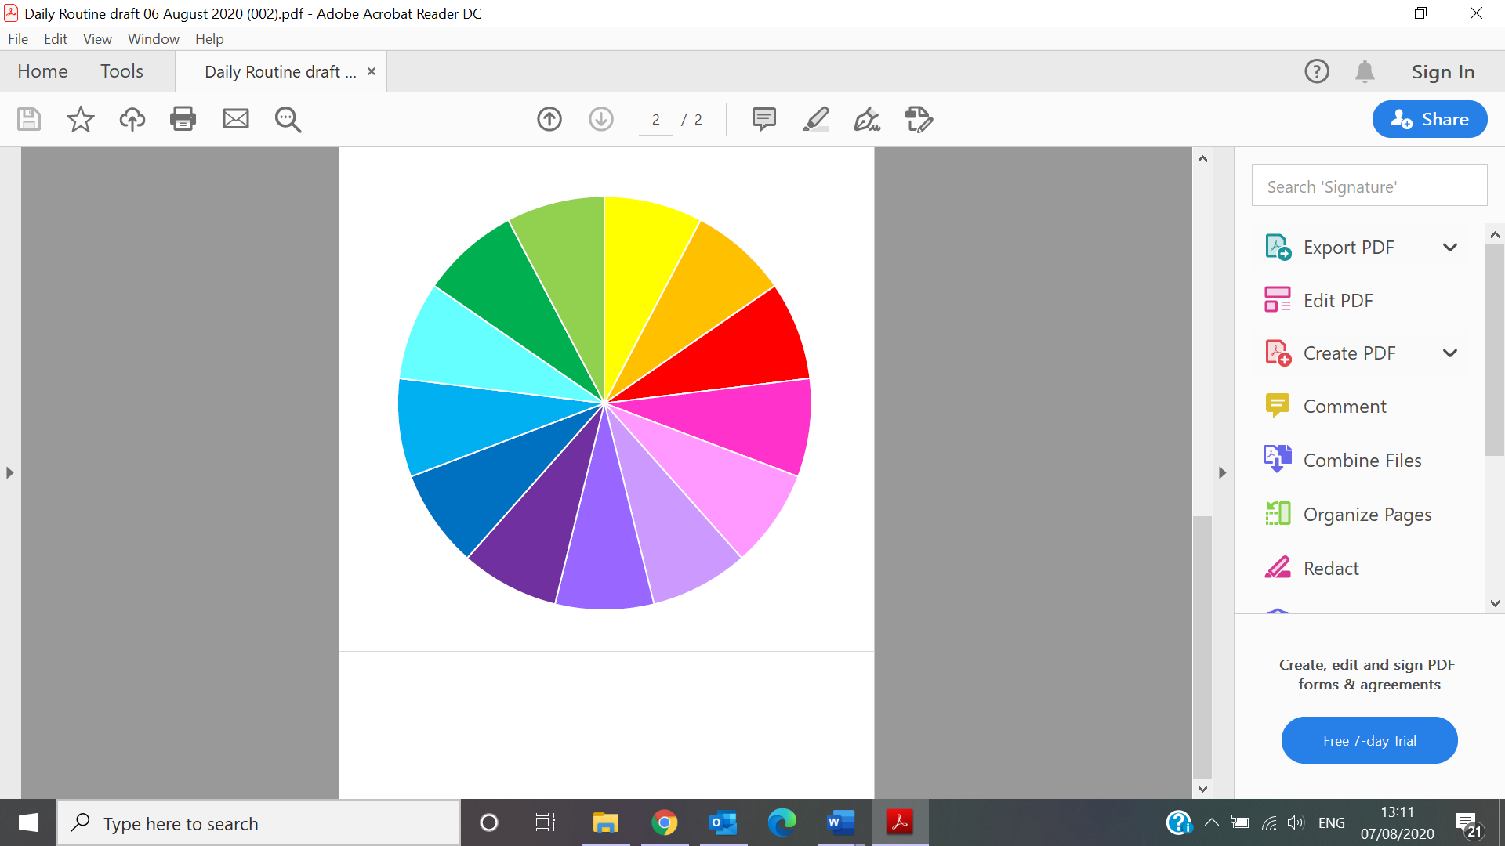

Baking

Music and Movement

Outings

Welcoming and Settling in

Arts and Crafts

Story Telling

Open ended play

Personal Care

Play

Outdoor Play

Resting and Relaxing

Eating

Sleeping

# Voluntary Notification Form

CCC Logo

**Voluntary Notification Form for a Person Providing a Home Based Childminding Service**

To: XXXXXX County Childcare Committee

I, _____________________________ hereby Voluntary Notify XXX County childcare Committee that I am providing / it is my intention to provide a home-based Childminding service that is exempt from the requirement to notify the Health Service Executive (HSE) under the Childcare Act 1991.

* I have read the ‘National Guidelines for Childminders’. I agree to comply with all the aspects of the guidelines.
* I agree to work with the Childminder Advisory Officer to access various supports, information, training, funding etc.
* I have completed the attached Self-Evaluation form.
* I agree that the HSE may be informed of my completed Voluntary Notification.

**This notice is given today ______________________________________________________**

**Childminders Details:**

**Name: _____________________________________________________________________**

**Address: ___________________________________________________________________**

**___________________________________________________________________________**

**___________________________________________________________________________**

**Phone: ____________________________ Mobile: ___________________________**

**Email: ______________________________________________________________________**

**My childminding Service operates from:**

**_____________ am to _________________ pm ____ days per week**

**Signature childminder:**

**________________________________________ Date: _________________________**

**Signature of Development Officer / CCC Representative:**

**________________________________________ Date: _________________________**

|  |  |  |
| --- | --- | --- |
| SUITABILITY OF THE PERSON | | Signature of Childminder |
| 1. | I am an adult who is genuinely interested in caring for children, has the ability to communicate with children, is of good character and is in good health. |  |
| 2. | I attest that I am free from any criminal conviction or pending investigation that would deem me unsuitable to have unsupervised care of children. I am willing to undergo a Garda Vetting procedure in the future if necessary. |  |
| 3. | I have provided at least two written references that attest to my good character and to my suitability to provide single-handed childcare for a group of pre-school children. *Copies of letters attached.* |  |
| 4. | I have trained in First Aid for Children and have up-to-date First Aid Certification dated: _____________ (*Copy of Certificate attached)* 🞏  ***Or***  I am willing to undertake First Aid Training for Children 🞏 |  |
| 5. | I have the following experience working with Children: |  |
| 6. | I have completed the following relevant training: |  |
| 7. | I plan to undertake the following relevant training |  |

|  |  |  |
| --- | --- | --- |
| WELL-BEING OF THE CHILD | | Signature of Childminder |
| 1. | I am concerned to providing quality childcare which ensures that the well-being and development of the child is paramount |  |
| 2. | I have written policies and procedures for my Childminding service and I will ensure that parents are aware of these. Samples available in Support Pack.  - Confidentiality 🞏  - Health and safety policies including a safety statement 🞏  - Child Protection 🞏  - Fire Safety Policy 🞏  - Positive Discipline Policy 🞏  - Partnership with Parents 🞏  - Equal Opportunities 🞏 |  |
| 3. | I have put in place a procedure for recording relevant information in relation to the child and ensure that parents are aware of this procedure:  - Daily attendance 🞏  - Child’s Information Record 🞏  - Daily Routine 🞏  - Menu Plans (ensuring healthy, balanced nutritional diet,  food stored correctly) 🞏  - Accident/Incident Form 🞏  - Medicine Administration Form 🞏 |  |
| 4. | I have 🞏 / plan to 🞏 …  …avail of Children First E-Learning Programme/ Always Children First Training Foundation Level |  |

|  |  |  |
| --- | --- | --- |
| PHYSICAL ENVIRONMENT | | Signature of Childminder |
| 1. | My home provides a secure and happy environment in which the health, safety and welfare of the child are assured, and in which the developmental needs of the child are met. |  |
| 2. | The areas of my home, indoors and out of doors, are in a proper state of repair and are fit for the purposes of Childminding. All are free of avoidable hazards |  |
| 3. | My home is clean, hygienic and safe: has stair gates, locks on cupboards, presses, doors as needed; and hazardous materials suitably stored. |  |
| 4. | There is a telephone on the premises. |  |
| 5. | Emergency contacts are posted in an easily accessible location and an emergency back-up person is available to me who can respond promptly |  |
| 6. | The exit doors, gates and perimeter of the home are secure. |  |
| 7. | There is adequate work and play space for all children and adults in the service. |  |

|  |  |  |
| --- | --- | --- |
| HEALTH AND SAFETY | | Signature of Childminder |
| 1. | I have health and safety procedures in place in my childminding service and can provide evidence of this. |  |
| 2. | I have health and safety procedures in place in my childminding service and can provide evidence of this. |  |
| 3. | I ensure good hygienic practices are followed at all times. |  |
| 4. | I have appropriate insurance cover for my childminding service  Copy Attached 🞏 |  |
| 5. | I have :  Properly equipped First Aid Kit 🞏  Fire fighting equipment/ blanket 🞏  Smoke Alarms 🞏 |  |
| 6. | Fire safety procedures are in place, including an evacuation plan.  *Copy attached* 🞏 |  |
| 7. | I have ensured that animals/pets on the premises do not put the health, safety or welfare of the children at risk. |  |

The following documentation must accompany this voluntary notification Self-Evaluation form:

* 2 References
* First Aid Certificate (if available)
* Copy of Relevant Insurance
* Copy of Fire Safety Procedure including Evacuation Plan

**For support and assistance in completing the Voluntary Notification Form and Self-Evaluation Form, contact:** Tel: Email:

**Disclaimer**

The information provided to the undersigned Development Officer (“the Officer”) in this Voluntary Notification Form (“the Form”) has been provided by (“the Childminder”) of as part of a voluntary self-evaluation process as set out in the National Guidelines for Childminders.

In signing this Form, the Officer acknowledges receipt of the information from the Childminder and thereby confirms that the Childminder has voluntary notified ___________ City/County Childcare Committee. Neither the Officer nor the Committee guarantees or warrants as to the truth, validity or accuracy of the information provided by the Childminder and the Childminder is solely responsible in this regard. The function of the Officer in receiving the information provided by the Childminder and signing this Form is solely to confirm that the Childminder has voluntarily notified the Committee. Neither the Officer nor the Committee accepts any responsibility, howsoever arising, in respect of any of the information provided in this Form, or the use thereof or reliance thereon by any party.

In signing this Form, the Childminder undertakes to and assures the Officer that the information provided to the Officer, and in turn to the Committee and any other third party (including the HSE) to which this Form may lawfully be given, is true, accurate and valid in every respect on the date of signing, and s/he accepts full responsibility in respect of the information provided in this Form, the use thereof and reliance thereon by any party. The Childminder is aware that the process of voluntary notification is a self-evaluation process and that s/he is required to complete the Form in good faith, and to provide true, accurate, valid and up-to-date information.

Signed: _________________________________________

Development Officer

Signed: _________________________________________

Childminder

Date: _________________________________________

1. See also [Management of Infectious Disease in Childcare Facilities and Other Childcare Settings](https://www.hpsc.ie/a-z/lifestages/childcare/File,13445,en.pdf), page 72 and 74 for other examples.
2. [Management of Infectious Disease in Childcare Facilities and Other Childcare Settings](https://www.hpsc.ie/a-z/lifestages/childcare/File,13445,en.pdf), page 75