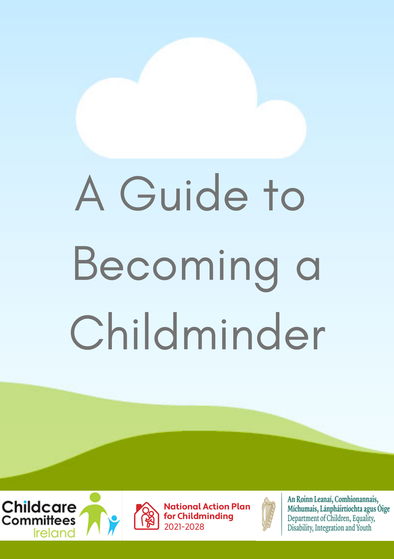

This document was developed by the Childminding Development Officer Team in September 2020 under the National Action Plan for Childminding 2021 – 2028. Version 2 updated September 2021.

The Childminding Development Officers provide support to the local City and County Childcare Committees to work with existing and potential childminders to deliver a high-quality early learning and care and/or school age service to meet the requirements of individual children, families and communities.

The Childminding Development Officer team would like to acknowledge that the material in this pack has been adapted from resources previously developed and published by the City and County Childcare Committees (CCCs) and Tusla.

Disclaimer:
The Childminding Development Officers have made every effort to ensure that all the information included in this publication is accurate and correct. However, under no circumstances will the board of any City/County Childcare Committee be liable in respect of any error(s), omissions, typographical errors or incorrect information therein.
The Childminding Development Officers assumes no liability whatsoever for any damage resulting from use of this publication, associated resources or its contents.

Contents Page

What is a Childminder? 4
Childminding as a Profession 4
How CCCs support Childminders 5
Childminding 5
Voluntary Notification 6
Tusla Registration 7
Garda Vetting 9
Child Protection and Welfare 9
Policies & Procedures 10
Developing a Record Keeping System 11
First Aid Requirement for Childminders 11
Insurance 12
Fire Safety Information and Regulations 13
Childminder Qualification Requirements 13
Aistear Síolta Practice Guide 13
Registering with Revenue 14
Childcare Services Relief 14
Planning Permission 14
The National Childcare Scheme (NCS) 15
Childminding Development Grants 15
Learner Fund Bursary for Childminders 15
Steps to Become a Professional Childminder 16
Useful Links 17

What is a Childminder?

A childminder cares for a small group of children of mixed ages in the childminder’s own home. Children are welcomed as individuals, they are offered affection and respect and their developmental and recreational needs are met. Childminders offer a flexible service, tailored to each child, thereby helping parents and guardians to balance their work and family commitments. A childminder negotiates and agrees her/his terms with parents. The child’s welfare must be the prime consideration of the childminder. Childminders have sole responsibility for the health, safety and wellbeing of each child entrusted to their care.

Childminding as a Profession

If you enjoy working with children, why not consider becoming a childminder?
Childminding can offer you an opportunity to:
- Earn a living by caring for other people’s children in your own home
- Become a self-employed Early Learning and Care / School Age Childcare provider
- Offer the National Childcare Scheme (NCS)
- Stay at home and care for your own children as well as caring for others
- Share in the care and development of children from birth to 14 years of age
- Avail of the Childcare Services Relief with Revenue
- Avail of information, networking and training supports from your local City / County Childcare Committee (CCC)
- Access the Childminding Development Grant and other funding opportunities
- Meet other childminders in your area and get to know your local community

How CCCs support Childminders

CCCs support childminders to:
- avail of relevant up to date childminding information
- develop appropriate Policies and Procedures
- access funding supports such as The Childminding Development Grant and Learner Fund Bursary for childminders
- participate in local network opportunities with other childminders
- avail of local training opportunities
- avail of the Childcare Services Relief with Revenue
- Voluntary Notify (if applicable)
- register with Tusla (if applicable)
- offer the National Childcare Scheme (if applicable)
- remove the isolation often experienced by childminders
- connect with parents who are seeking childminding care
- have their names included on a public list of childminders which is made available to parents

You can find your local CCC information here

Childminding

Childminders care for children in their own home. Many childminding services are not required to register with Tusla (see below).
These childminders may choose to contact their local City/County Childcare Committee (CCC) or/and Childminding Ireland to avail of information, support, network and training opportunities and grants.

Childminders exempt from Tusla registration under section 58L of the cHILDCARE Act (1991) are as follows:
(a) the care of one or more children undertaken by a relative of the child or children or the spouse of such relative
(b) a person taking care of one or more children of the same family and no other such children (other than that person’s own such children) in that person’s home
(c) a person taking care of not more than 3 children of different families (other than that person’s own such children) in that person’s home.

A childminder is exempt from registering with Tusla if they care for a mix of Early Years and School Age children (up to a maximum of 6 children) as set out below:
No. of pre-school children being cared for | Maximum no. of school age children
0 | 6
1 | 5
2 | 4
3* | 3
3* | 0
*no more than 2 babies under 15 months

Voluntary Notification

Childminders who are minding 3 or less children (in their own home) or who are legally exempt from registering with Tusla may choose to voluntarily notify that they are providing a childminding service by contacting their local CCC and avail of information, supports, network, training opportunities and grants.
CCCs who offer Voluntary Notification support childminders to complete the process which considers the four nationally recognised core areas where certain requirements should be met by childminders:
- Suitability of the person
The childminder must be a person aged 18 or over who is genuinely interested in caring for children and is of a suitable character to do so.

- Wellbeing of the Child
The childminder must have a commitment to providing quality childcare which ensures that the wellbeing and development of the child is paramount.
- Physical Environment
The childminder’s home should provide a secure and happy environment in which the health, safety and welfare of the child is assured and in which the developmental needs of the child are met.
- Health & Safety
The childminder must provide evidence that adequate health and safety procedures are in place.

Tusla Registration

Certain categories of childminders are legally obliged to register their childminding service with Tusla and are subject to Inspection: childminders who wish to care for 4 or more preschool children or care for 7 or more school age children or a mix of both.

Who are Tusla?
TUSLA, the Child and Family Agency, are the dedicated State agency responsible for improving wellbeing and outcomes for children.

Tusla’s Early Years Inspectorate is the independent statutory regulator of Early Years Services in Ireland. Certain categories of childminders are legally obliged to Register with Tusla that they are providing a childminding service, while others are not obliged to register. This is to ensure that children attending Childminding Services are safe, receive appropriate care and have a positive experience where they can develop and learn in a quality service.

Who is obliged to register with TUSLA?
- Childminders who wish to care for 4 or more preschool children (only preschool children)
- Childminders who wish to care for 7 or more school age children (only school age children)
- Childminders who care for a mix of preschool and school age children, i.e. if caring for 4 or more preschool children and a small number of school age children or 7 or more school age children and a small number of preschool children
If a childminder wishes to register their service with Tusla, it is a legal requirement that they must apply at least 3 months in advance of minding 4 or more children.

In relation to Preschool age children: A childminder should look after no more than 5 preschool children (birth – 6 years). Childminders who care for 4 or more ’minded’ preschool children are legally required to register their childminding service with Tusla prior to caring for the 4th minded child.

In relation to School Age Childcare: If a childminder cares for school age children only, the childminder can care for up to 12 children in the childminder’s home. A childminder can care for up to 6 school age children without having to register with Tusla, however the care of 7 or more school age children requires such childminders to register their childminding service with Tusla.

Childminders who care for a mix of preschool and school age children: The maximum numbers of each that a childminder can care for at the same time is as follows:
No. of preschool children cared for  (0 – 6 years) | Maximum no of school age children than can be cared for  (6+ years)
1 | 10
2 | 7
3 | 5
4 | 2
5 | 1

All scenarios in the table above will require a childminder to register their service with Tusla. For further details click here.
For further information, please request a copy of Tusla Registration: A Guide for Childminders which is available from your local CCC

Garda Vetting

All Tusla registered childminders must have Garda Vetting, but best practice would indicate that all childminders and their emergency backup contact should be Garda Vetted.
To apply for Garda Vetting, you must contact Barnardos’ Vetting Service directly.
Alternatively, Barnardos can be contacted on:
Phone: 021 4547060
Email: vetting@barnardos.ie
If a childminder is a member of Early Childhood Ireland they can be vetted as members through Early Childhood Ireland.

Child Protection and Welfare

Children First relates to the recognition of child abuse and neglect, the reporting of same to Tusla - Child and Family Agency, and the best practice which organisations should adhere to, to keep children safe while availing of their services. Non statutory obligations for all persons coming into contact with children are set out in the Children First Guidance. The Children First Act 2015 sets out additional statutory obligations for defined categories of persons and for organisations providing relevant services to children.
For further information: Cosaint Leanaí Child Safeguarding: National Child Safeguarding Programme Early Learning & Care

Children First Child Protection training Programme
Tusla Children First E-learning Programme
Tusla worked with the DCYA (now Department of Children, Equality, Disability, Integration & Youth (DCEDIY)) and HSE to develop a universal e-learning training programme called ‘Introduction to Children First’. The programme is based on Children First: National Guidance for the Protection and Welfare of Children and the Children First Act 2015. The programme takes approximately 1.5 hours to complete but it can be done in a number of sittings. To adhere to best practice in relation to Child Protection & Welfare, all childminders should complete the E-learning programme.
Always Children First Training – Foundation Level
Always Children First training aims to create an awareness of Child Protection and Welfare issues in the Early Years sector. The aim of the training is to help childminders understand how to safeguard children and report Child Protection and Welfare concerns. This training may be accessed through your local City/County Childcare Committee. A prerequisite of attending this training is that childminders have completed the Tusla Children First E-Learning Programme.

Policies & Procedures

A childminder must develop and review policies, procedures and statements. Policies, procedures and statements standardise the childminder’s approach to implementing best practice, support communication with parents and ensure compliance with the regulations, if applicable.
A childminder’s policies and procedures should represent their individual service and reflect their childminding service as a ‘home from home’ to the children and families in their care.

Communication of policies, procedures and statements
Policies, procedures and statements including any updates, should be communicated and available to parents and guardians. Parents and guardians confirm and sign that they have read and accepted the policies, procedures and statements of the service.
Templates and samples are available from your local CCC on request to support childminders in developing or revising their own set of required policies, procedures and statements.
For further information, please request a copy of Childminding Sample Policies and Procedures which are available from your local CCC
or
Click Here

Developing a Record Keeping System

All businesses are required to maintain adequate records and childminding services are no different. Not only are childminders required to maintain accounting records for their business, but it is recommended that all childminding services maintain certain types of childcare specific records.

Why develop a record keeping system?
Records offer childminders guidance and inform parents of best practice, regulations and protect the children in the childminders care.
Records show that childminders are working in a professional manner, are organised and care about the work they do. Setting up an appropriate record keeping system will make childminders work easier.
The following records are examples of those recommended for childminders however this list is not exhaustive:
- Child’s Information Record
- Children’s Register/ Attendance
- Accident/ Incident Form
- Medicine Administration Form
- Fire and Safety Procedures including Evacuation Plan
- Safety Statement
For further information, please request a copy of Childminding Sample Record Keeping Forms which are available from your local CCC
or
Click Here

First Aid Requirement for Childminders

As a measure of best practice all childminders are encouraged to participate in First Aid for children. Childminders who wish to complete the Voluntary Notification process are required to complete First Aid for children.
A registered childminder trained in First Aid Responder (FAR) should be available for children attending the childminding service, as per the Quality & Regulatory Framework: Childminding.

Insurance

All childminders should ensure that the childminding service is adequately insured, evidenced by a current certificate of insurance. Childminders who are registered with Tusla are obliged to adhere to the requirements as outlined in the Quality & Regulatory Framework: Childminding.
For childminders working from their own home, Childminding Insurance is important for their own protection. Many home insurance policies cover childminding for up to 2 children, which may be extended to mind up to 6 children. For specific childminding insurance, there are policies, such as that offered by Childminding Ireland, which are tailored packages for minding up to 6 children.

Childminding Ireland Members Insurance Package
As insured members, childminders have access to the full range of services:– including free advertising space on the website. The insurance is comprehensive and provides:
- Public Liability covering insurable accidents
- All risks cover on equipment relating to Childminding, with low €125 excess
- Outings, including swimming with increased ratio of 1 adult to 5 Children
- Loss of Income if your service closes due to certified illness
- Employer Liability, to include helpers or substitutes
- Legal advice and counselling helpline

Childminders caring for more than 6 children should contact their broker or home insurance company to ensure they have adequate insurance cover.

Car Insurance & Child car seats
All childminders should check with their car insurer to clarify if they are covered to carry minded children. As childminders are paid to mind these children, the car insurance company may ask childminders to get Class 2 insurance to cover the use of their car for business purposes.
Suitable child car seats are essential if childminders are transporting children as part of their working day, all childminders have a duty of care to ensure the safety of children.
See the Road Safety Authority (RSA) advice in relation to child car seats.

Fire Safety iNFORMATION AND rEGULATIONS

It is important and considered best practice that all childminders have Fire Safety policies and procedures in place. This includes an emergency evacuation plan, relevant fire equipment and a fire drill should be carried out monthly with drills being recorded and documented as recommended in Fire Safety in Preschools (1999).

Childminder Qualification Requirements

Childminders who are not obliged to register with Tusla are not required to have a childcare qualification, however all childminders are encouraged to continue their professional development and participate in relevant childcare training as a measure of best practice.
Childminders who register with Tusla as a pre-school service are required to hold at least a major award in Early Childhood Care and Education at Level 5 on the National Qualifications Framework prior to registration. This includes the care of a mix of preschool and school age children. (Please note that childminders who deliver the ECCE scheme must hold a major award in Early Childhood Care and Education at Level 6).
There is currently no qualification requirement for childminders registered with Tusla as a School Age Childcare service. This includes the care of a mix of preschool and school age children.

Aistear Síolta Practice Guide

The purpose of the Aistear Síolta Practice Guide is to support those working with children including childminders in using Aistear: the Early Childhood Curriculum Framework (2009) and Síolta, The National Quality Framework for Early Childhood Education (2006) together, to develop the quality of their curriculum and in doing so, to better support children’s learning and development.
Aistear describes the types of learning that are important for children in their early years and is designed for use in a number of different early years’ settings, including childminding services.
Síolta is designed to define, assess and support the improvement of quality across all aspects of practice in Early Childhood Care and Education (ECCE) settings where children aged birth to six years are present, including childminding services.

Registering with Revenue

The main legal obligation when becoming self-employed is that childminders must register as a self-employed person with Revenue. Childminders pay tax on the profits from their business and on any other income that they have. See Registering for Tax for guidance on registering as a self-employed person.

Childcare Services Relief

The Childcare Services Relief allows childminders who are Voluntary Notified/Known to their local CCC to avail of tax relief on their childminding income. The Childcare Services Relief is available to childminders who care for 3 children or less in their own home at any one time and earn up to €15,000.
The purpose of the relief is to provide an exemption from income tax, where certain conditions are met, to individuals who provide childminding services in their own homes. To avail of this, childminders should register with Revenue on-line services (ROS).
Further information is available in Guidelines on Planning a Childminding Business in your own home from your local CCC.

Planning Permission

The current planning exemptions apply to Early Years Services. Childminders who mind no more than 6 children using existing rooms in their home, do not require planning permission.

The National Childcare Scheme

The National Childcare Scheme (NCS) is a DCEDIY funded scheme which provides financial support towards the cost of childcare to eligible families with children aged between 24 weeks and 15 years who are attending any participating Tusla registered childcare service, including any Tusla registered childminder and School Age Childcare services.

Childminding development grants

The Childminding Development Grant (CMDG) offers an incentive, in the form of a small capital grant, to Childminders to enhance and support their awareness of quality childcare.
The CMDG is designed to assist childminders, already providing a childminding service in their own homes, to enhance safety/quality in the service through the purchase of small capital items, equipment, toys, or minor adaptation costs. It may also give financial assistance to new or prospective childminders with their initial set up costs.
All applicants must be committed to maintaining/improving the quality of their childminding service.

Learner Fund bursary for childminders

The Learner Fund Bursary for childminders provides subsidy funding to support childminders who hold a Level 5 or a Level 6 award on the National Framework of Qualifications. The qualification must be on the DCEDIY Early Years recognised Qualification list.
The Learner Fund Graduate Bursary provides subsidy funding for Early Learning and Care practitioners (which includes childminders) who hold awards at Level 7, 8 and 9 on the National Framework of Qualifications. The qualification must be on the DCEDIY Early Years recognised Qualification list.
Childminders who are registered with Tusla as a School-Age Childcare service only are not eligible for the Learner Fund Graduate Bursary.

Steps to becomE a Professional Childminder

- Contact the Development Officer in your local City/County Childcare Committee.
- Participate in Continuous Professional Development (CPD) such as First Aid, Children First E-Learning programme and CPD resources available on National Action Plan for Childminding 2021-2028 and First 5
- Arrange a support visit (where applicable) to access advice on the physical layout and set up of the service.
- Organise 2 written references and take copies to share with potential parents.
- Organise insurance cover.
- Develop your own Childminding Policies & Procedures by consulting the samples available in the ‘Childminding Sample Policies & Procedures’.
- Develop your own Childminding Record Keeping system by consulting the samples available in the ‘Childminding Sample Record Keeping Forms’.
- Complete and return the Voluntary Notification Form to your local CCC.
- If required to do so, register your childminding service with Tusla.
- Register your new childminding business with Revenue.
- Decide on your fee policy and preferred hours of work etc.
- Request that your contact details be included in your local CCC Directory of ELC/SAC Services.
- Participate in organised childcare networks to meet other childminders.
- Design a flyer and place in your local supermarket, library, parent & toddler group preschool / school etc.
- Place advertisement on social media platforms or in the local newspapers.

Useful links

For further information on childminding please see National Action Plan for Childminding 2021-2028
The following resources to support childminders in developing their business are available from your local CCC:
- Childminding Sample Policies and Procedures
- Childminding Sample Record Keeping Forms
- Guidelines on Planning a Childminding Business in your own home
For further advice and support on becoming a childminder please contact your local CCC. You can find your local CCC information here

Other useful links:
- First 5
- Tusla
- National Voluntary Childcare Organisations:
- Barnardos
- Childminding Ireland
- Early Childhood Ireland
- Irish Steiner Kindergarten Association
- National Childhood Network
- National Parents Council
- St. Nicholas Montessori Society of Ireland

