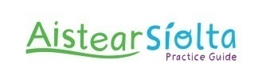 Introducing the Aistear Siolta Practice Guide 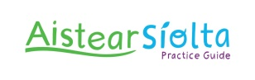
SCCC will run an Introduction to the Aistear Siolta Practice Guide on Tuesday 7th February in the offices of SCCC from 6.30 – 9pm.
This workshop has been developed as part of the National Siolta Aistear Initiative and will describe the content of the Aistear Siolta Practice Guide in addition to giving explanation on an emergent, inquiry-based curriculum and the role of curriculum developer.
Following attendance at Introduction to the Aistear Siolta Practice Guide workshop, attendees will be eligible to submit an Expression of Interest to be part of the Aistear strand of the National Siolta Aistear Initiative which offers 10 hours of workshop and 4 hours of coaching support free of charge.
The Aistear Workshops and Coaching is a National Pilot as part of the National Siolta Aistear Initiative which is funded by Department of Children and Youth Affairs (DCYA) and is developed in collaboration with the Department of Education and Skills (DES). Early Years services taking part in this National Pilot will be acknowledged, in addition to all participants receiving certification for attendance.
The aim of the Aistear workshops and coaching is to:
- Support Participants’ understanding and use of the Aistear Siolta Practice Guide
- To improve the quality of Early Childhood curriculum for children from birth to six year
- Support participants on their quality ‘journey’
- Support participants to meet requirements under Tusla and DES inspections
Please note this workshop is open to all Early Years practitioners working with all age groups – Babies, Wobblers, Toddlers and Pre School.
If you would like to attend the Introduction to the Aistear Siolta Practice Guide workshop please complete required information below and return to SCCC by Friday 3rd February 2017.
-------------------------------------------------------------------------------------------------------------
Introduction to the Aistear Siolta Practice Guide
SCCC Offices, Tuesday 7th February 2017 - 6.30pm – 9pm
Name of Service:

Tel. No.: E-mail:

Name of Participant –

Name of Participant –

Name of Participant –

Name of Participant –

